Fractional CMO & Marketing Newsletter – April 2019

Do we Still Need Business Cards?
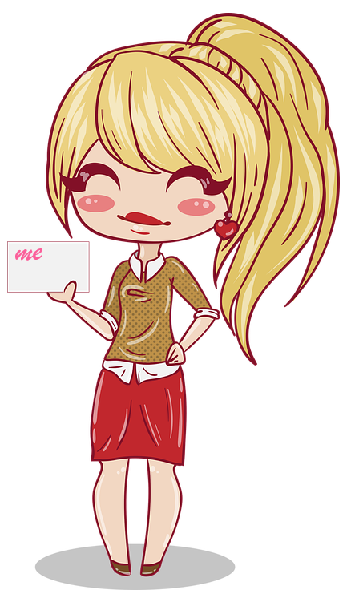

When we start working with new clients, we conduct a very thorough marketing needs assessment which we developed based on decades of experience and working with hundreds of clients. Among other things, this comprehensive assessment examines every aspect of the clients marketing efforts and evaluates their effectiveness.

One of the items we look at carefully is the business card the client uses, and how they use it. We know that business cards work, and work well in most business situations. Many business people already have decent looking business cards and with only a few tweaks in design and production techniques we can make them very effective. But you wouldn’t believe how many people either have inadequate business cards, or don’t have them at all!

Here are a few types of business card ‘attitudes’ we come across:

- The Frugal: To save money on printing new cards this person continues to use old business cards, even though they contain outdated information. In some cases, as these business cards are given out, handwritten corrections or additions are made.
- The Apologizer: You’ve heard it before: “Yes, I have a card, but I don’t have one on me”. This business person does have a nice box with hundreds of shiny business cards somewhere in his or her office… but never on their person, or close by.
- The Non-Believer: This business person finds it necessary to explain to every person who asks them for a business card that “I don’t believe in business cards! nobody wants business cards any more…”. You see, this person does not believe business cards are necessary in this modern and digital society we live in, yet, ironically, constantly runs into those who ask for his or her business card.
- The Rebel: This person has a unique card that often does not resemble any of the company’s branding standards and might not be fitting for the audience it is intended to.

Business cards have a long and intriguing history (see article below), and they are still serving a purpose. This does not mean that business cards must be the same plain-old business cards used decades ago – there are ways to modernize your business card to make it look and feel relevant, as well as stand out.

Consider the following for your next business card:

- Materials: Business cards do not have to be made of paper. You can get your business card made of plastic (even clear plastic), wood, aluminum, titanium, and more. And if you decide to go with paper, choose interesting paper – There are many choices of texture, weights, and coatings that can transform ordinary cards into conversation pieces.
- Printing: Explore your options when printing – don’t settle for one or two colors as your only option. Most places offer foil options, raised lettering, spot UV coating, embossing, debossing, stamping, and die-cutting.
- Size and Shape: You don’t have to have to have the 3.5” X 2” run-of-the-mill business card. You can have a larger card, a smaller card, a square card, a round card, an oval-shaped card, and more. All these options are out there for you to choose from.
- Electronic Business Cards: There is nothing that prevents you from also having a digital business card. One easy way to have and share a digital business card is to save a high-quality image of your business card on your mobile device, and whenever asked for one, send it as a message to the person who asked to have it.
Another simple way to share a business card is to use a short-code texting service. With this option you use a texting service provider who sends your contact information and message to anyone who texts them a code or keyword. Once they receive your contact information texted back to them, all they need to do is save it to their address book on their mobile device.

Business cards are still being used widely in business interactions – They are definitely not relics from years gone by! Smart and modern design combined with contemporary production techniques can help you make that crucial first impression a great one!

There is more to business cards than just their format and materials – what should go on them and what shouldn’t, must be considered too. If you would like us to take a look at your current cards or help you design a slick new one, call us or write to us – we will be happy to speak with you about it, without any obligation on your part.

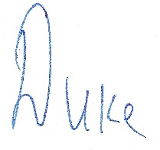
Duke Merhavy, MBA, Ph.D.
President & Chief Marketing Officer

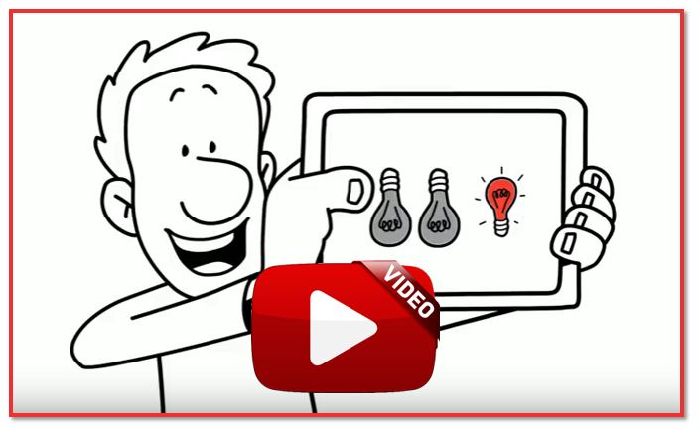
What Is Fractional CMO & Marketing?

Fractional CMO & Marketing is ‘Your Smart Marketing Formula’ when you need expert marketing leadership and marketing services to accelerate growth and improve profitability, but you’re not quite ready to hire a full-time Chief Marketing Officer or your own marketing department

Our unique arrangement is the most efficient, innovative, and cost-effective formula for you. Click on the image on the right to watch a short video.

The Ingenious History of the Business Card
By Polly Stroup, Editor and Copywriter
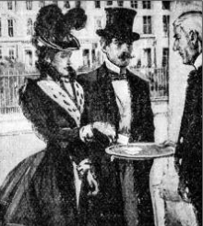
The concept of business cards has been around a long time. Sitting in wallets, and desk drawers everywhere, few people know how these compact marketing tools came to be.

The earliest examples of business cards were called "Visiting Cards," said to have appeared in China and France in the 15th century. These small cards were designed to “promote” the cardholder’s self-proclaimed virtues - describing how “intelligent, fascinating, and important” they were. If a person wanted to meet with another person, they would initiate that meeting by sending a visiting card. People also used them when visiting an "elite establishment" in order to prove credentials before they were invited in.

In the 17th century European merchants invented trade cards to act as miniature brochures. These ornate pieces of advertisement were the size of a playing card and engraved, embossed, and often included gold elements. Very specific etiquette surrounded the usage of the trade cards. These artful masterpieces of information were used for all manners of social interactions - from business dealings to dating.

So, the next time you hand out or receive a business card, think about the centuries of history behind these powerful little attention grabbers!

Take Advantage of Us

Give us a call at 888-412-2236 or use the button below to request a complimentary Marketing Needs Assessment, or to ask us a question regarding your most pressing marketing or sales challenges.
Request a Complimentary Marketing Needs Assessment

